- Linear relation:
If we don’t use an activation function, each layer will just behave like a straight line (linear function). That means as the input increases, the output also increases or decreases in a fixed proportion.
- Bending:
When we apply an activation function (like Sigmoid, Tanh, or ReLU), the output no longer follows a straight line. Instead, it forms a curve or even “stops” at some points (e.g., in ReLU, negative inputs are mapped to 0).
So, the input-output relationship is no longer a straight line — it becomes a curved or warped shape.
- Non-linearity:
This curving or bending is what we call non-linearity. Non-linearity makes neural networks much more powerful, because it allows them to learn complex patterns, such as in images, speech, or medical data.
Activation functions change the input-output relationship from a straight line into a curve, and this bending is what we call non-linearity.
Linear case (no activation function)
Equation:
y=2x+1
If inputs are:
x=[−2,−1,0,1,2]
Then outputs are:
y=[−3,−1,1,3,5]
This is a straight line. Every step in input gives a fixed change in output.
Non-linear case (with ReLU activation)
Equation:
y=f(z),
z=2x+1,
f(z)=max(0,z)
For the same inputs:
- x=−2⇒ z=−3⇒ f(z)=0
- x=−1⇒ z=−1⇒ f(z)=0
- x=0⇒ z=1⇒ f(z)=1
- x=1⇒ z=3⇒ f(z)=3
- x=2 ⇒ z=5⇒ f(z)=5
So outputs are:
y=[0,0,1,3,5]
Some signals were blocked (negative values became 0), and others passed through. This created a bend in the graph at 0 — which is the non-linearity.
ReLU activation function
ReLU also known as Rectified Linear Unit is an activation function that passes only positive signals and blocks negative ones, which helps neural networks learn complex, non-linear patterns.
It is defined as:
f(x)=max(0,x)
That means:
- If the input x>0→ output is x
- If the input x≤0 → output is 0.
TanH activation function
Tanh (hyperbolic tangent) activation squashes input values into the range -1 to 1, giving a smooth S-shaped curve centered at 0, making it useful for handling both negative and positive signals.
Output range: (-1, 1)
Shape: S-shaped curve (sigmoid-like but centered at 0)
- For large positive x, tanh(x)→1
- For large negative x, tanh(x)→ −1
- At x=0, tanh(x)=0
Logistic Activation function
The logistic (sigmoid) activation function squashes inputs into the range (0, 1), making it useful for probability-based outputs.
Looks like an S-curve.
Smoothly transitions from 0 to 1.
$$σ(x)=\frac{1}{1+e^{-x}}$$
Where:
- $x$ = input to the neuron (weighted sum of inputs + bias)
- $σ(x)$ = output, which always lies between 0 and 1

Softmax Activation Function
The softmax activation function converts a vector of raw scores (logits) into probabilities that sum to 1.
Mathematically, for $N$ classes:
$$\text{softmax}\left(z_{i}\right)=\frac{e^{z_{i}}}{\sum_{j=1}^{N}{e^{z_{j}}}}$$
Where:
- $z_{i}$ = raw score (logit) for class $i$
- $N$ = total number of classes
- Output = probability of class $i$
Key properties:
- Probabilities are all between 0 and 1
- Probabilities sum to 1
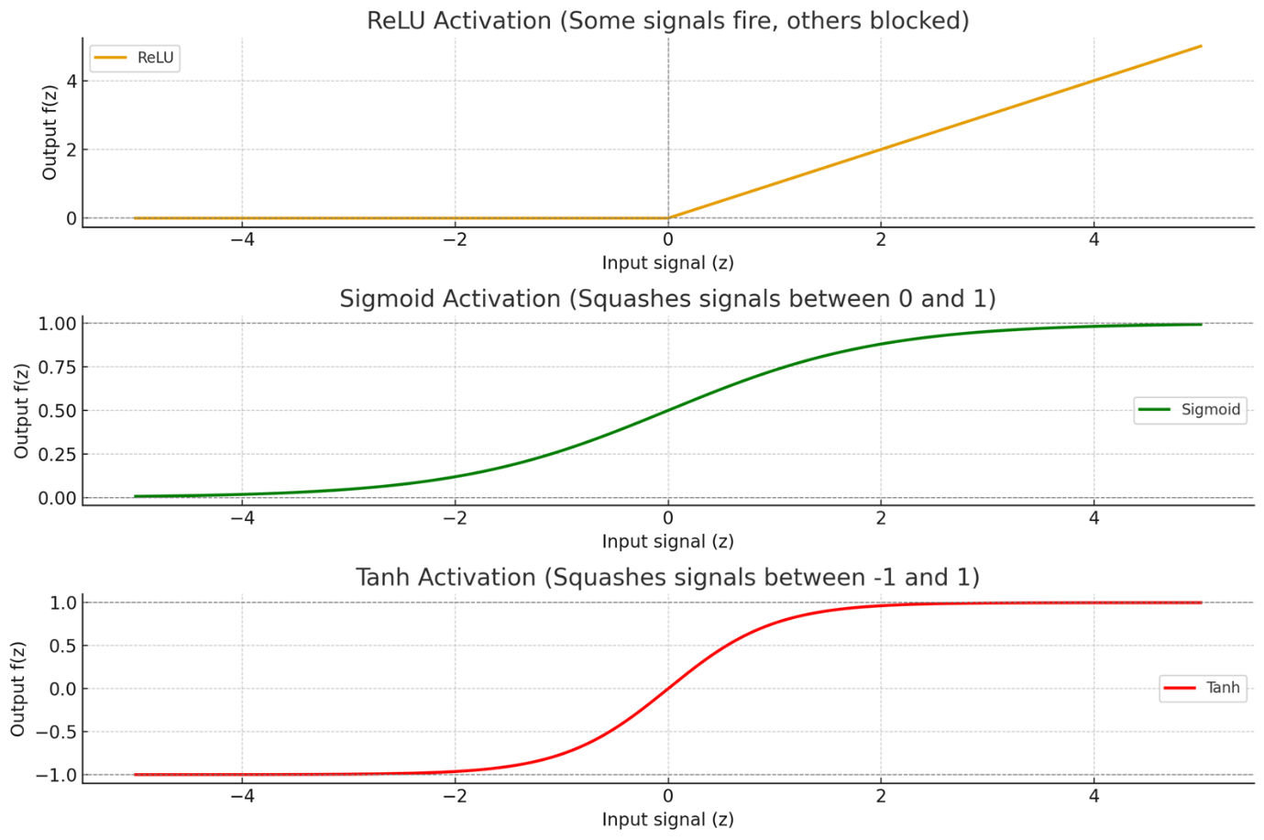

Activation Function | Typical Use in Hidden Layer | Typical Use in Output Layer
ReLU | Yes | No
tanh | Yes | No/Rarely
Sigmoid | No/Rarely | Yes (binary)
Softmax | No | Yes (multiclass)

